**Project Design Phase**

**Solution Architecture**

|  |  |
| --- | --- |
| Date | 26 -06-2025 |
| Team ID | LTVIP2025TMID59482 |
| Project Name | ALPHA Works – FreelanceFinder |
| Maximum Marks | 4 Marks |

**Solution Architecture:**

To provide a **user-friendly, secure, and scalable freelancing platform** that bridges the gap between clients and skilled freelancers, ensuring smooth project collaboration from start to finish.

* Effortless Project Posting and Bidding
* End-to-End Freelancer & Client Management
* Scalable user authentication and authorization
* Secure and trackable payment transactions
* Reliable real-time chat and notifications

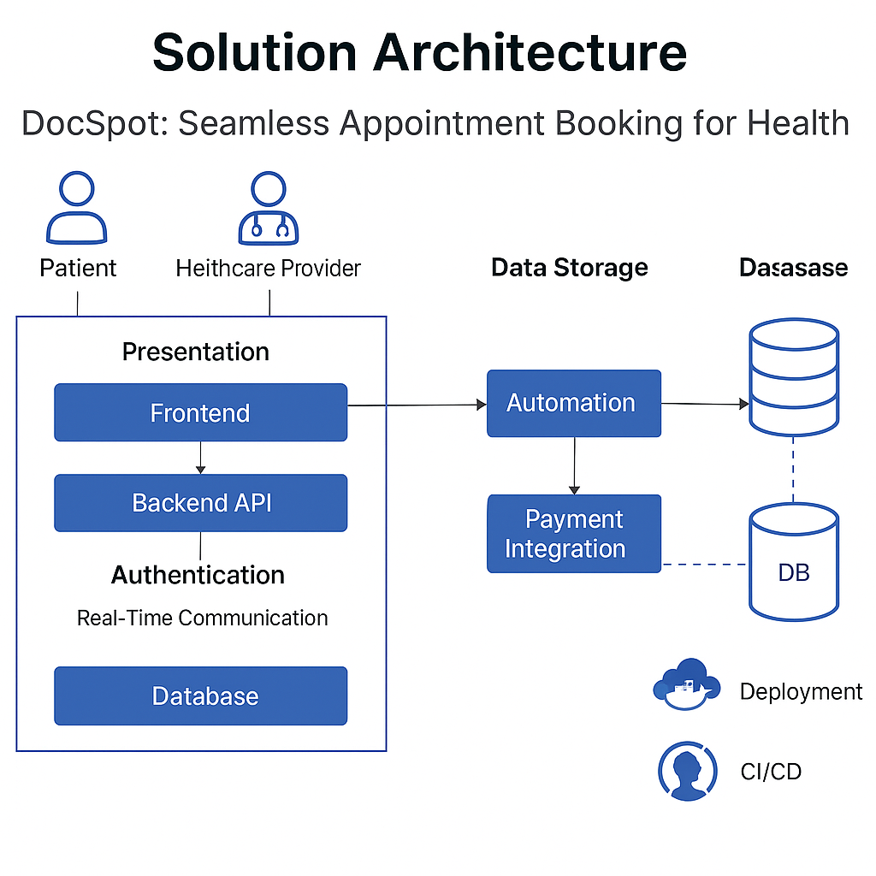**Example - Solution Architecture Diagram:**